**Vivekanand Education Society’s Institute of Technology**

**Department of AI&DS Engineering**



**Subject: Social Media Analytics**

**Class: D16AD**

| ROLL NO:30 | NAME: [SUHANEE KANDALKAR](mailto:2021.suhanee.kandalkar@ves.ac.in) | | |
| --- | --- | --- | --- |
| EXPERIMENT NO:2 | TITLE:To Collect Data from Social Media Platform using suitable Web Scraping Tools. | | |
| DOP: |  | DOS: |  |
| GRADES: | LOs MAPPED: | | SIGNATURE: |

**Aim**: To Collect Data from Social Media Platform using suitable Web Scraping Tools.

**Theory:**

Web scraping and web crawling are two related but distinct methods used for extracting data from websites, which is often employed in research or data collection projects like yours.

### **Web Scraping:**

Web scraping refers to the process of extracting data from websites in a structured format. It involves sending HTTP requests to a webpage, downloading the content, and then parsing that content to extract relevant information such as text, images, links, etc. This data can then be stored in a local file or database for further analysis.

For your experiment on collecting data from social media platforms, web scraping would allow you to target specific data like posts, comments, user information, hashtags, or other elements of interest from a platform’s pages.

### **Web Crawling:**

Web crawling, on the other hand, is the process of systematically browsing and indexing websites across the internet, much like how search engines like Google index content. A web crawler (or bot) starts at a single webpage, follows links from that page to others, and continues this process recursively, effectively "crawling" through the web. Web crawling is typically used to gather data from large volumes of interconnected web pages, while web scraping focuses more on collecting specific, targeted information from selected pages.

### **Web Scraping for Social Media Data:**

When collecting data from social media platforms using web scraping tools, it’s crucial to choose appropriate tools that are capable of navigating these platforms' complex structures, handling challenges like dynamic content loading (JavaScript), and dealing with issues like rate limits or CAPTCHAs.

#### **Key Considerations for Web Scraping Social Media:**

1. **Legal and Ethical Concerns:** Many social media platforms have terms of service that may restrict or prohibit scraping. It's important to ensure that you comply with these policies and understand the ethical implications of collecting and using this data.
2. **API Access:** Some social media platforms provide official APIs (e.g., Twitter API, Facebook Graph API, etc.), which offer a more structured and legal way to collect data. APIs are often preferred over scraping as they are designed for data access and tend to be more stable and reliable.
3. **Captcha and Rate Limiting:** Many social media platforms have security measures in place to prevent scraping. These include CAPTCHAs (which require human verification) and rate-limiting (which restricts the number of requests you can make in a given time period).

### **Tools for Web Scraping:**

* **BeautifulSoup (Python):** A Python library for parsing HTML and XML documents, useful for scraping static pages.
* **Selenium (Python, JavaScript):** A web browser automation tool, great for scraping dynamic content (pages that rely on JavaScript to load content).
* **Scrapy (Python):** A powerful web scraping framework that can handle large-scale scraping projects, including crawling through multiple pages.
* **Octoparse:** A no-code tool that helps users to easily extract data from websites.
* **ParseHub:** A visual web scraping tool that can extract data from dynamic websites.

### **Typical Web Scraping Process:**

1. **Identify Target Data:** Determine the exact information you need (e.g., user posts, comments, hashtags) from the social media platform.
2. **Select Web Scraping Tools:** Choose a suitable tool based on the platform’s structure (static vs. dynamic content).
3. **Send Requests to Platform Pages:** Use HTTP requests to fetch the HTML of the target page(s).
4. **Parse the Data:** Extract the relevant data using parsing libraries like BeautifulSoup (for static content) or Selenium (for dynamic content).
5. **Store Data:** Save the collected data in a structured format such as a CSV, JSON file, or database for further analysis.

### **Why is Web Crawling or Scraping Important?**

Web crawling and scraping are important because they enable automated data extraction from the vast amount of information available on the web. As websites are dynamic and constantly updated, crawling allows bots to collect real-time data, while scraping helps to structure and extract specific data from web pages.

Here's why they are used:

* **Efficiency:** Automating the process of data collection saves time compared to manual methods.
* **Access to Large Datasets:** The web is full of valuable information that may not be available through other means (e.g., APIs). Web scraping helps extract data from such sources.
* **Real-Time Information:** Web scraping can be done frequently to monitor and update data, making it suitable for tasks like monitoring social media, news sites, or product prices.
* **Cost-Effective:** Web scraping reduces the need for expensive datasets or subscription-based services by gathering publicly available data.

### **Applications and Use Cases of Web Crawling and Scraping:**

Web crawling and scraping are used in various fields for different applications. Here are some of the major ones:

#### **1. Social Media Data Collection**

* **Use Case:** Researchers or marketers collect data from platforms like Twitter, Facebook, or Instagram to analyze trends, sentiments, or user behavior.
* **Example:** Analyzing the sentiment of posts or comments related to a specific product or hashtag.

#### **2. Price Monitoring and Comparison**

* **Use Case:** Retailers or e-commerce platforms use web scraping to monitor competitors' prices and adjust their own pricing strategies accordingly.
* **Example:** Scraping product prices from Amazon, eBay, or other online stores to monitor price fluctuations.

#### **3. SEO and Content Analysis**

* **Use Case:** Companies or digital marketers use web crawling to analyze the content of competitor websites, identify keywords, and improve their SEO strategies.
* **Example:** Extracting metadata (titles, descriptions, etc.) from a competitor’s pages for competitive analysis.

#### **4. Market Research and Competitive Analysis**

* **Use Case:** Businesses gather insights about market trends, customer behavior, and competitor activities.
* **Example:** Scraping customer reviews from product pages to understand customer sentiment and improve a product or service.

#### **5. News Aggregation and Monitoring**

* **Use Case:** Web scraping is used to aggregate news from various sources, track trends, and monitor mentions of specific topics or keywords.
* **Example:** Crawling news websites to collect articles related to a certain political issue or event.

#### **6. Job Listings and Recruitment**

* **Use Case:** Companies or job platforms scrape job boards (like LinkedIn, Indeed) to collect job listings, analyze hiring trends, or aggregate opportunities for job seekers.
* **Example:** Scraping job postings to create a job aggregator website.

#### **7. Financial Data Collection**

* **Use Case:** Investors or financial analysts scrape financial websites to track stock prices, company financials, and other important data for decision-making.
* **Example:** Collecting stock data from financial news sites and using it for algorithmic trading.

#### **8. Academic Research**

* **Use Case:** Researchers use web scraping to collect scientific papers, articles, or other academic resources for their studies.
* **Example:** Scraping databases like PubMed or Google Scholar to gather academic papers on a particular topic.

#### **9. Real Estate Data**

* **Use Case:** Real estate companies or individuals scrape property listings from real estate websites to track market trends or evaluate prices.
* **Example:** Scraping Zillow for property listings, including prices, features, and location data.

#### **10. Event Aggregation**

* **Use Case:** Companies scrape event listings to create comprehensive event calendars or track local happenings for marketing purposes.
* **Example:** Aggregating concerts, conferences, or festivals data from multiple websites into one platform.

#### **11. E-commerce Product Data Collection**

* **Use Case:** E-commerce platforms collect data on product listings (including descriptions, reviews, ratings, etc.) to analyze trends and better market products.
* **Example:** Scraping product data from Etsy or eBay for trend analysis or to update inventories automatically.

#### **12. Sports Analytics**

* **Use Case:** Scraping sports websites for player statistics, scores, or upcoming events.
* **Example:** Collecting historical performance data of teams and players from sports websites to develop betting models or fantasy sports algorithms.

#### **13. Travel and Airline Data**

* **Use Case:** Travel agencies or aggregators use web scraping to collect flight and hotel data across different booking platforms.
* **Example:** Aggregating flight prices from websites like Kayak or Skyscanner to provide users with the best deals.

#### **14. Government and Legal Data**

* **Use Case:** Legal firms or public institutions scrape government websites to collect regulations, public records, or court decisions.
* **Example:** Scraping court case data or regulations from government sites to track changes in laws and policies.

### **Key Differences Between Web Crawling and Web Scraping:**

* **Web Crawling:** Primarily involves navigating through multiple web pages via links to gather large datasets or index content. Crawlers are used to discover new and updated content, often for search engines.
* **Web Scraping:** Involves extracting specific pieces of data from one or more pages (e.g., text, images, tables) for analysis, often targeting structured data like pricing, user reviews, or product specifications.

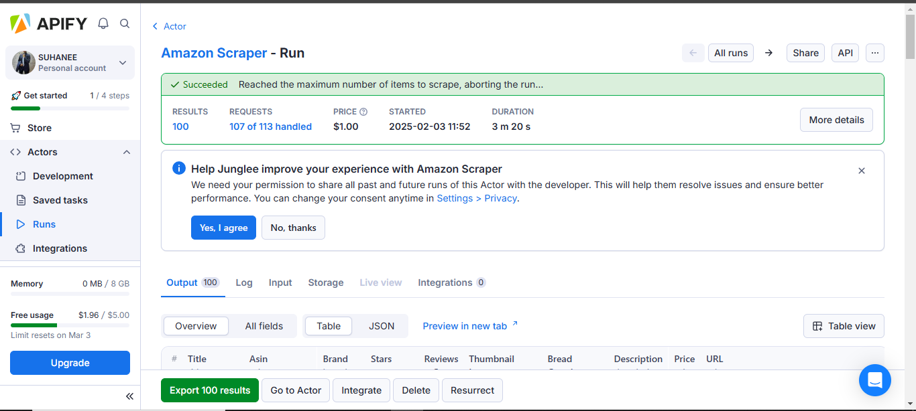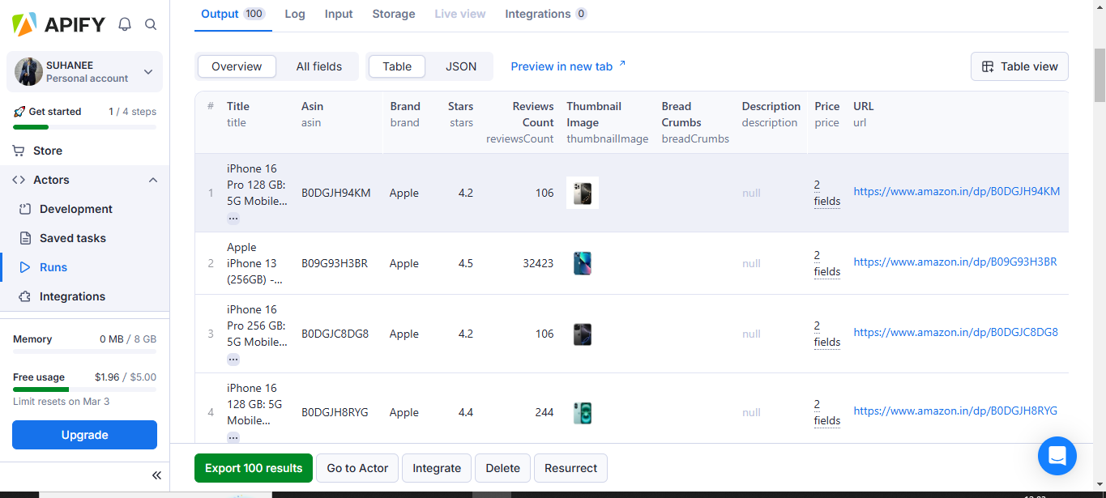

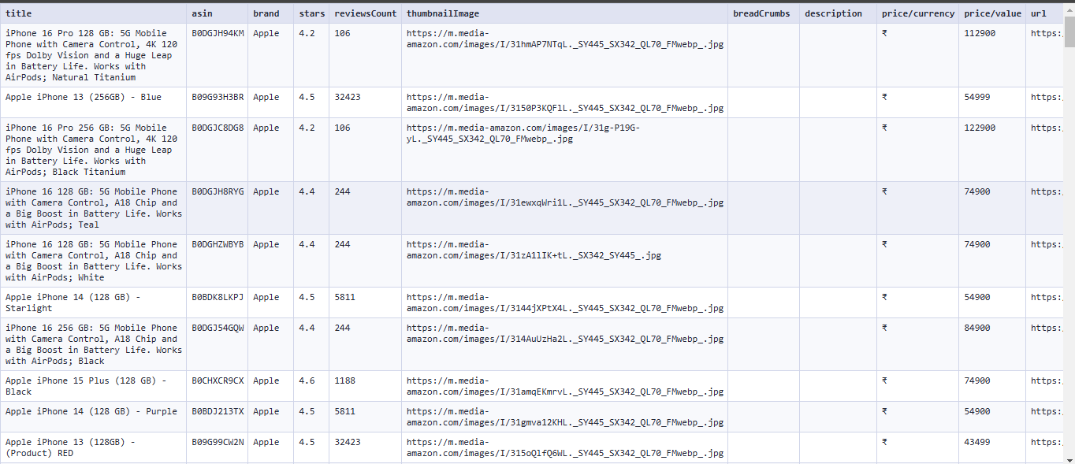

**Conclusion:**

In this experiment, you used **Apify** to scrape data from **Amazon** about the **iPhone**, efficiently collecting structured information like prices, features, and reviews. This automated process saved time and provided valuable insights for tasks like price comparison, market research, and trend analysis. However, it's important to ensure your scraping complies with **Amazon's terms of service** and respects any restrictions they have in place. Overall, Apify made the data collection process faster and more effective while providing useful, actionable insights.